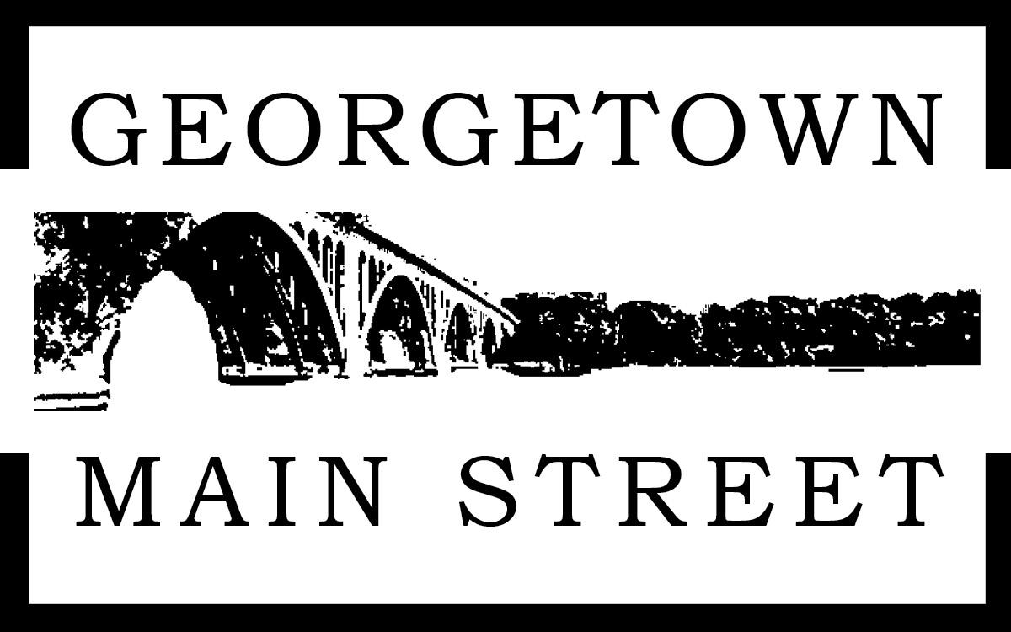
Georgetown Main Street
2022 Small Business Grants

THIS IS NOT THE APPLICATION, THIS IS JUST THE GUIDELINES.
PLEASE APPLY ONLINE AT:

https://www.cognitoforms.com/GEORGETOWNMAINSTREET/FY22GeorgetownMainStreetGrant

SUMMARY

The Georgetown Main Street (GMS) program will provide a grant of $3,000 for small businesses in the Main Street corridor. Only small businesses located within the Georgetown Main Street boundaries are eligible to apply. Funds can be used for projects that will help businesses grow and stabilize after the COVID-19 pandemic. Due to multiple other grants that fund these expenses, operational expenses such as rent and payroll are not eligible under this program. Funds can be used for technical assistance, business development, exterior and storefront improvements, interior renovations, security improvements, and/or equipment.

Applications will open on March 4 and will close on April 1. No exceptions will be considered.

Grant awards will be announced by April 15, 2022. All project activities must be completed by September 1, 2022. Please read the guidance herein for information on how to apply. If you have any questions or need assistance preparing your application, please contact Rachel Shank, Executive Director of GMS at rachel@georgetownmainstreet.com.

APPLICATION PROCESS

Information sessions for all interested applicants will be held on:
Session #1: Wednesday, March 10, 2022, 10:00 am - https://us02web.zoom.us/j/82545657966
- +13017158592,,82545657966# US (Washington DC)
- +13126266799,,82545657966# US (Chicago)
Session #2: Monday, March 14, 2022, 6:00 pm - https://us02web.zoom.us/j/88504362835
- +13017158592,,88504362835# US (Washington DC)
- +16465588656,,88504362835# US (New York)

If you are not able to attend, the information sessions will be recorded. Email rachel@georgetownmainstreet.com to request the recording.

Applications will be submitted via online application found at www.georgetownmainstreet.com/grants. If the applicant is unable to submit all documents via online submission, please contact Georgetown Main Street to make alternative arrangements.

Applications must be received no later than Friday, April 1, 2022 by 5:00 pm.

Applicants will be notified of their award status no later than Friday, April 15.
CONFIDENTIALITY: Information provided as a part of this grant application shall only be used in evaluating the proposed project. The information will not be made public or shared with any government entity.

SITE VISIT
GMS staff will be conducting site visits to all grantees between May and July to evaluate progress for project implementation. Grantees will be informed in advance of the exact date of the site visit. A final site visit will be made upon project completion of the funded project in coordination with the business owner but no later than August 30, 2022.

GRANT FINAL REPORT
The grant period for each grant is approximately five months from the date of the award. All funds must be expended and reported with documentation submitted to GMS upon completion of the funded project but no later than September 1st, 2022. The Grantees final report should include:
- Brief description of completed project.
- Copies of receipts, including cancelled checks, credit card receipts, and/or paid invoices for all grant expenditures.
- If applicable: Before and After photos of improvements funded by the grant.
- If applicable: Copies of any documents or materials developed with grant funds

Any funds not expended as proposed by September 15, 2022, must be returned to GMS for reallocation to support other small businesses in the corridor.

Evaluation:
The GMS grant selection committee will determine the grant recipients based on a need and community impact criteria point scale, for a total of 100 points.
- 85 points for project description
- 10 points for project budget
- Up to 5 points if your business has not received other grants

APPLICANT ELIGIBILITY REQUIREMENTS

To qualify for a grant, the applicant must:
- Be incorporated in the District of Columbia, demonstrated by a current business license.
- One of the following:
  - Have at least 1 year left in your lease. You will need to submit a copy of your lease.
  - Own the property. If you own your property, you will need to provide proof of ownership.
- Be located within the boundaries of the Georgetown Main Street program. See map below and confirm eligibility using your business address here.
- Submit a complete application by the deadline of April 1, 2022 at 5:00 pm.

GMS will not provide a grant to any of the following types of entities:
- Adult entertainment
- Gas stations
- Banks
- Home-based businesses
- Professional Services (i.e. real estate, accounting, legal firms, etc...)
- Churches and nonprofit organizations without storefront retail
- District of Columbia government agencies
- Any business located outside of the GMS boundaries. Check here.
- Any organization that discriminates against individuals on the basis of race, color, religion, sex, national origin, age, marital status, personal appearance, sexual orientation, family responsibilities, political affiliation, physical handicap, or any other protected class under the DC Human Rights Act and/or any federal anti-discrimination statute or regulation

PROJECT ELIGIBILITY REQUIREMENTS

Funds can be used for technical assistance, business development, exterior and storefront improvements, interior renovations, security improvements and/or equipment. The combined amount requested for funding cannot exceed $3,000. Note that each business is responsible for determining any applicable permit or licensing requirements and obtaining required permissions prior to beginning the project.

Technical Assistance*: Eligibility under technical assistance includes hiring a consultant to provide technical assistance under specific topics:

- Accounting
- Financial management
- Marketing
- Quickbooks training
- Website development/improvement

*If you are interested in applying for technical assistance please let us know before starting your application as we might be able to connect you with free resources.

Exterior Improvements: Eligible exterior and storefront improvement projects are smaller design fixes and not expansive façade improvements. Applicants who are leasing properties must obtain written approval from the property owner(s) and obtain any applicable permit and/or license for physical improvements or alterations to commercial property. Examples of eligible improvements are the following:
- Business Signage
- Paint Touch-Ups
- Awning
- Doors and Windows
- Patios or decks (with evidence of proper Summer Garden or Sidewalk Cafe permits)
- Security grate removal

Interior Improvements: Eligible interior improvement projects are primarily decorative, minor remodels, and permanent equipment. Applicants who are leasing properties must obtain written approval from the property owner(s) and obtain any applicable permit and/or license for physical improvements or alterations to commercial property, or demonstrate proposed project is allowed in existing lease. Examples of eligible interior improvements include the following:
- Interior walls, floors, ceilings
- Interior decor and remodels
- Equipment (see below for more information)

Equipment: Eligible equipment include:
- Heating, air conditioning or ventilation systems; purchased, installed or repaired
- Permanent equipment such as refrigerators, stoves, ovens, ventilation hoods, dishwashers and point of sale systems.
- Storage or shelving; purchases, installed or repaired
- Point of Sale installation

Security Improvements: Eligible expenses under security include:
- Security cameras; purchase and installation (Must apply for DC government rebate to receive up to $750 on equipment costs through the Office of Victim Services and Justice Grants (OVSJG). Applicant is responsible for reading eligibility for rebate and for applying for it.)

Ineligible Expenses:
- Financing of existing debt, rent, payroll, day-to-day operational costs, maintenance and moving expenses, and loan interest.

TIMELINE

Friday, March 4, 2022 | Application opens
Wednesday, March 10, 2022, 10:00 am | Information Session #1
Monday, March 14, 2022, 6:00 pm | Information Session #2
Friday, April 1, 2022 | Application is due
April 9 - April 13, 2022 | GMS Grants Committee will review and score applications
Friday, April 15, 2022 | Awards announced
By June, 2022 | Grant Checks Awarded
May-July, 2022 | Site visits for project progress, if applicable
September 1, 2022 | Projects and final site visit/reporting completed

GRANT FINAL REPORT
The grant period for each grant is approximately five months from the date of the award. All funds must be expended and reported with documentation submitted to Georgetown Main Street upon completion of the funded project but no later than Wednesday, September 15, 2022. The Grantees final report should include:
- Brief description of completed project.
- Copies of receipts, including cancelled checks, receipts, and/or paid invoices for all grant expenditures.
- If applicable: Before and After photos of improvements funded by the grant.
- If applicable: Copies of any documents or materials developed with grant funds.

Any funds not expended as proposed by Wednesday, September 15, 2022, must be returned to Georgetown Main Street for reallocation to support other small businesses in Georgetown.

2022 GRANT APPLICATION EXAMPLE
Please find the application online after 3/4/2022 at: georgetownmainstreet.com/grants
SECTION 1. APPLICANT INFORMATION
BUSINESS (0 points)
This information pertains to the business that will benefit from the Small Business Grant.

Registered Business Name:
Trade name/DBA (if different from Registered Name):
Brief description of type of business (e.g., restaurant, book store, dentist):
Year business was established in Georgetown:
Business Address:
Mailing Address (if different from business address):
Business Phone:
Website:
Social Media sites (Facebook, Instagram, TikTok, Twitter, Yelp):
Number of FT Employees:
Number of PT Employees:

BUSINESS OWNER
This section pertains to the business owner(s) who is applying for the Small Business Grant. If there are multiple business owners, all owners must sign the Application [SECTION 5].
Business Owner(s) Name(s):
Business Owner(s) Cell Phone Number(s):
Business Owner(s) Email(s):
Optional:
Gender Business owner identifies with: 口Male 口Female 口Other 口Prefer not to answer
Are you of Hispanic, Latino, or of Spanish origin? 口 Yes 口No 口Prefer not to answer
Race Business owner identifies with (check all that apply):

口 White
口Black or African American
口American Indian or Alaskan Native
口Asian
口 Native Hawaiian and Pacific Islander
口Other______________________

Country of origin:______________
SECTION 2. PROJECT DESCRIPTION

PROJECT DESCRIPTION AND COMMUNITY IMPACT (85 total points)
This section pertains to the proposed project activities and its community impact for which the applicant seeks funding. Consideration will be given to well-written and thoughtful responses.

What is the problem and how is it impacting your business (no more than 300 words) (20 points):

How will the proposed project solve the problem (no more than 300 words) (40 points):

How does your business engage with and support the Georgetown community? (no more than 300 words) (10 points):

Please include participation in events, donations or support to community organizations, organizational membership, etc...

Please describe how you plan to implement your project in terms of timeline, use of contractors, and any required permits or permissions (no more than 300 words) (15 points):

Note: projects must be completed by September 1. If you are doing construction work or anything that requires permits, you must submit evidence that you are in contact with contractors

SECTION 3. PROJECT BUDGET

TOTAL PROJECT COSTS (10 points)
This section pertains to the proposed project costs.

Please provide a summary of costs for the proposed project, such as materials, labor, installation, etc. Each line should list the Item, Item Cost, and Source of Funding to cover the item’s cost. If the total project cost is greater than the amount requested from GMS’ grant, please identify the expected source of additional funding (e.g., GMS grant, loan, other grant, business operating funds, etc.). Feel free to include a narrative justification if applicable.

Item | Item Cost | Source of Funding
 | $
 | $
 | $
 | $
 | $
 | $
TOTAL PROJECT COST | $
Total grant request from GMS | $

OTHER GRANTS

Did you receive any of the following grants? If so, indicate the grant amount.
$______ Restaurant Revitalization Fund
$______ Great Streets Grant
$______ Bridge Fund Grant
$______ Georgetown Main Street Grant 2021, 2019
$______ Other Grant (please describe) _____________________________________________
SECTION 5. APPLICATION CHECKLIST

Please use this Checklist to confirm all required documents are included in the final application submission.

🗸 Complete responses to all questions asked in the application.

🗸 Verify your business is located within the Georgetown Main Street boundaries.

🗸 Uploaded copy of lease showing at least 1 year remaining or proof of ownership.

🗸 Uploaded copy or photograph of business owner’s Business License valid in Washington, DC.

If proposed application is for physical improvements to the space:

🗸 If applicant is leasing the property: uploaded a signed permission from landlord allowing proposed project improvements to the property (see example, below).

🗸 Upload quote or estimate of proposed interior or exterior improvements.

🗸 Upload quote or estimate of proposed interior or exterior improvements.

